**Automatic Detection of Rocks Using U-Net Network and Calculating Volumes and 3D areas**

**A Fast Method of Detecting Rock Blocks and Calculating Volumes and 3D Areas**

Ali Polat

**Abstract**

Rockfall events are a type of natural disaster that causes loss of life and property in the world. The risk of rockfall can be eliminated by using rockfall prevention methods. To choose the most suitable method, projecting studies should be carried out. This study aims to automatically detect rock blocks in a region and calculate their volumes and 3D surface areas. For this purpose, U-Net segmentation method and Python software language were used. DenseNet121 transfer learning method based on convolutional neural networks was used for feature extraction. The data set was created from the orthophoto image obtained by an unmanned aerial vehicle (UAV). Using the random sampling method, 369 images were selected for training and 191 images for testing. As a result of the analysis, the mean IOU (Intersection Over Union) was calculated as 85% for training and 84% for testing. The trained model was applied to the study area and 3111 rock blocks were detected. This file is saved with coordinates and can be open in any GIS software and its geometrical properties can be calculated. The volumes and 3D surface areas of the rock blocks were calculated with Python software as 275.93 m3 and 2615.23 m2, respectively. With this study, rock blocks can be detected automatically, and their volumes and 3D surface areas can be measured. These results can be used in the selection of rockfall prevention methods. In addition, the codes used in this study can automatically detect different geological formations from aerial photographs. Also, volume and 3D area algorithms developed in this study can be used to calculate different types of objects.

**Keywords:** Rock segmentation, U-Net, convolutional neural networks, Rockfall, Volume and 3D surface area calculation, Unmanned Air Vehicle (UAV)

1. **Introduction**

In many parts of the world, loss of life and property is experienced, and large-scale economic losses occur due to natural disasters. One of these natural disasters is rockfall events. Rockfalls are a type of slope instability in which blocks of rock confined to discontinuities move very rapidly from the source region (Varnes, 1978; Hutchinson, 1988; Cruden and Varnes, 1996). Due to the high velocity during the event, rockfalls can be very dangerous for structures in their route depending on the block size. Although it is a type of disaster that affects small areas, its consequences can be very serious. That's why rockfall prevention studies are important. There are also studies on this subject in the literature [liu et al. 2022, Ji et al. 2022, Keskin and Polat (2022), kainthola et al. (2023), Cao et al. 2024]. Some preliminary studies are needed to develop a prevention method. One of them is the detection of rock blocks and the calculation of their volume. In this study, rock blocks were segmented, and their volumes were calculated. There are various studies on rock segmentation in the literature [7yayin].

In 2006, Dunlop [dunlop] developed a technique for characterization of rocks using albedo, colour, texture and shape features. In that work rocks in natural scenes are segmented and located with an accurate boundary. For segmentation purpose top-down and bottom-up knowledge are combined, and geologic rock analysis performed successfully.

In the study carried out by Song [song] in this area in 2006, segmentation studies of rocks on Mars were carried out in order to plan the route and determine the landing areas. Texture-based image segmentation and edge-flow driven active contour has been developed. Wavelet based local transform, multi-resolution histograms, and inter-scale decision were combined and used for rock segmentation. As a result of the experiments, reliable rock segmentation results were obtained by Song.

The place of visual navigation in planetary rover autonomy is crucial. Rock segmentation is an important and challenging task for rover autonomy due to the high computational load and real-time requirement. Kuang et al. [kuang] propose a rock segmentation network (NI-U-Net++) to aid in the visual navigation of rovers. The created model consists of two stages. In the first step, called pre-training, synthetic rock images are created and then the generated images are used to pre-train the NI-U-Net++ network. The second phase, transfer-training, fine-tunes the pre-trained NI-U-Net++ network with real-life images.

Guo et al. [guo] proposed an adaptive watershed segmentation method based on distance transformation for blasted rock piles images. They obtained 95.65% segmentation accuracy for limestone and granite rock blocks with area over 100cm2.

Segmentation of rocks is important in mining as well as in geology. Segmentation is used in this area to determine the size distribution of rock fragments, to organize and optimize blasting, and to reduce environmental impact. For this purpose, Malladi et al. [malladietal] proposed a simple superpixel algorithm called Superpixels Using Morphology (SUM), which uses a watershed transformation approach to generate superpixels; and made a study comparing some of the current superpixel algorithms on rock images.

Recently, various deep learning and machine learning algorithms, including Convolutional Neural Networks (CNN), have been proposed by researchers working on rock segmentation. Karimpouli and Tahmasebi [karimpouli2] used convolutional autoencoder networks called SegNet for segmentation of digital rock images. Due to the limited number of rock images, cross-correlation based simulation was applied to increase the number of images. 20 images taken from Berea sandstone were used as dataset. As a result of the tests, they obtained an accuracy value of 96%.

Xue at al. [xue] made rock segmentation study for a different purpose; they proposed the rock segmentation visual system to assist Tunnel Boring Machine (TBM) driving. TBM is an essential equipment for digging long-range tunnels. They applied different deep learning network for semantic segmentation of rocks.

In the above studies, rock segmentation was carried out for different purposes. In this study, rock segmentation was carried out as a necessary preliminary study in the development of rockfall prevention methods. Rock blocks were detected precisely in a fast, economical and safe way. In addition, the volume and 3D surface areas of rock blocks were calculated. The methods and algorithms used in the study can be used in many fields such as engineering applications, and geological-geomorphological studies.

* 1. Study area

The study area is in the north of Karasar village, which is approximately 156 km away from Sivas city (Figure 1). This area consists of Middle Miocene aged agglomerate and tuff units (MTA 1/25000) (Figure 2a). This unite was defined as Adatepe volcanites according to Yılmaz (2004). The unit consists of black, red-brown, and brown-black colored basaltic lava flows and less commonly agglomerate and tuffs. The rock blocks in this unit expose a risk of rockfall. Lower Miocene aged sandstone-mudstone-limestone units are observed in the settlement area (Karasar village) and vicinity.

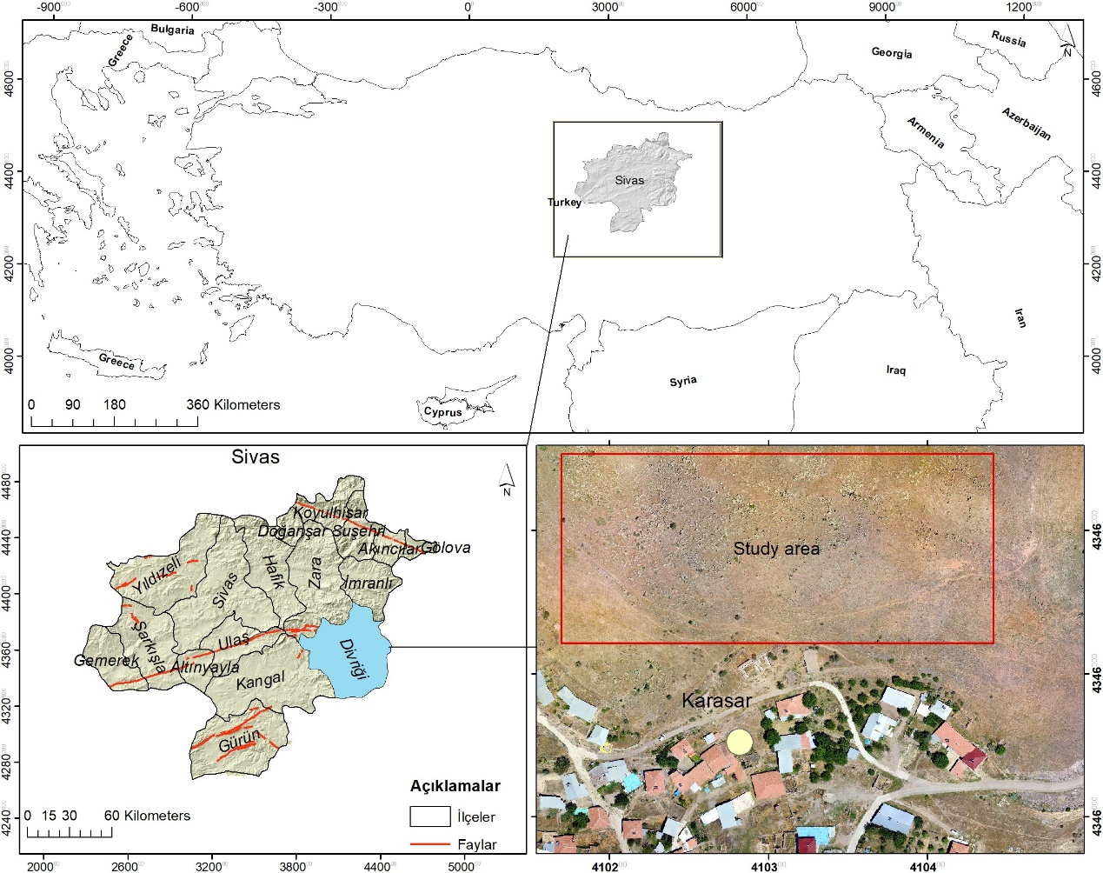

Fig. 1: Location map.

Karasar village is located on the slopes of a hill. The bedrock on the hill is heavily fractured and cracked. There are many rock blocks that have fallen from the upper parts of the slope (Figure 2b, c). The sizes of these blocks vary from 0.5 m3 to 15 m3. Rapid temperature changes, heavy snow and precipitation, freeze-thaw, earthquake, and human-induced causes increase the risk of rockfall in the region.

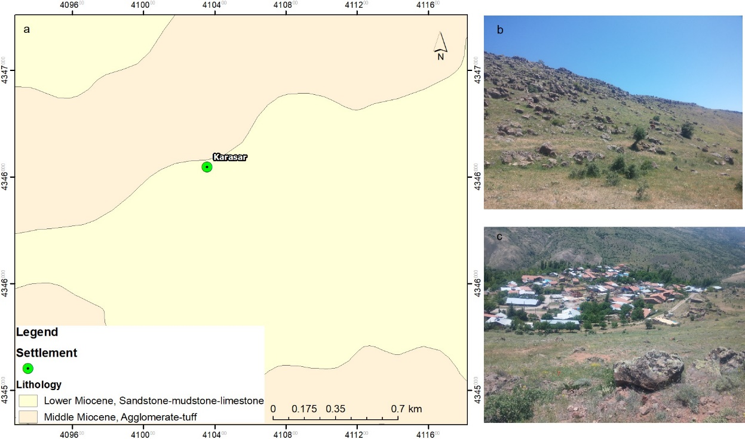

Fig.2: Geological map (1/25000 scale geological map of General Directorate of Mineral Research and Explorations) (a), rock blocks (b), settlement and rocks (c)

1. **Methodology**

Creating the dataset is a big problem for classification or segmentation processes. In this study, Unmanned Air Vehicle (UAV) was used to collect data. An orthophoto image of the region was created from aerial photographs obtained by UAV. An area was selected to create train images. Rock blocks within this area were labelled and mask images were created. Then segmentation process was completed by Python and necessary libraries, and the results were converted to the polygon as a vector file (Fig.1). Moreover, the volumes of all the rocks were calculated.

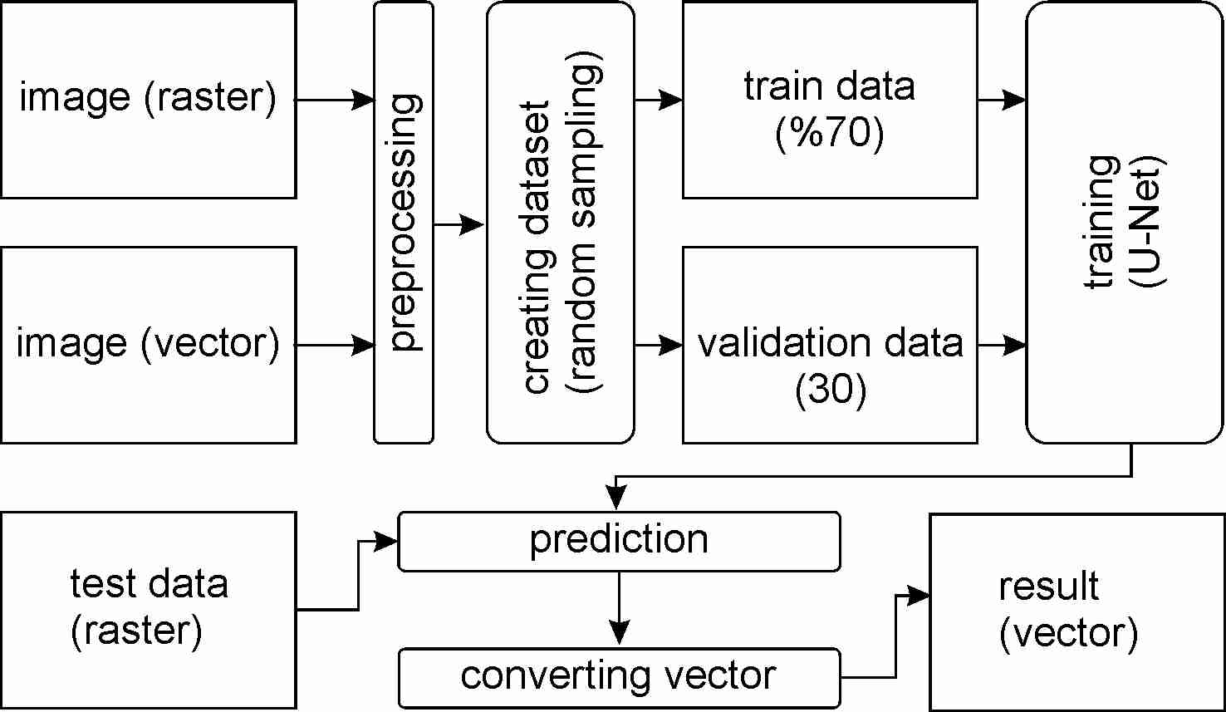

Fig. 1 Workflow diagram

* 1. Data preparation

In this study required data was collected by UAV. DJI phantom 3-Pro was used for image acquisition. First, the area to be flown is determined, then the necessary parameters for image acquisition are entered by the Pix4d Capture software. These parameters were chosen as follows.

Flight altitude (altitude): 100 m.

Flight speed (speed): Fast

Camera angle (Angle): 70o

Overlap: 80%

The flight was carried out by the "Double Grid" method. The model of UAV used in this study does not have an obstacle detecting feature. Therefore, when determining the height, it is necessary to pay attention to the nearby power lines, tall buildings, trees, and peaks of hills.

The camera model (FC00X) of UAV has 4000x3000 resolution, 3.61 mm focal length and 1.56 x 1.56 µm pixel dimensions. After the flight, 284 images were obtained, and these images were processed with the Pix4Dmapper software. As a result, an orthophoto image with a resolution of 3.51 cm/pixel and a dimension of 2329x1587 was created.

An area was selected to create train and test images from large orthophoto image. This area was selected randomly. Then all rocks seen on the image were drawn on by GIS software. This file was saved as a vector file, and it will be used as mask data in segmentation processes. After this process, we have created the image and mask files.

A deep learning model requires the same sizes of images. That's why a single image needs to be split into patches. The patch dimension was used as 256×256. Train-test splitting size was selected as %66 for training data and %34 for testing data. The large image was split into 9 part to avoid sampling from the same regions. Areas 1,5,9 were selected for creating test images. Train images were selected from the others (2,3,4,6,7,8) areas (Fig.2). A total of 600 images (256×256) were selected, 369 images for training and 191 images for testing. The same processes were applied to extract the mask images.

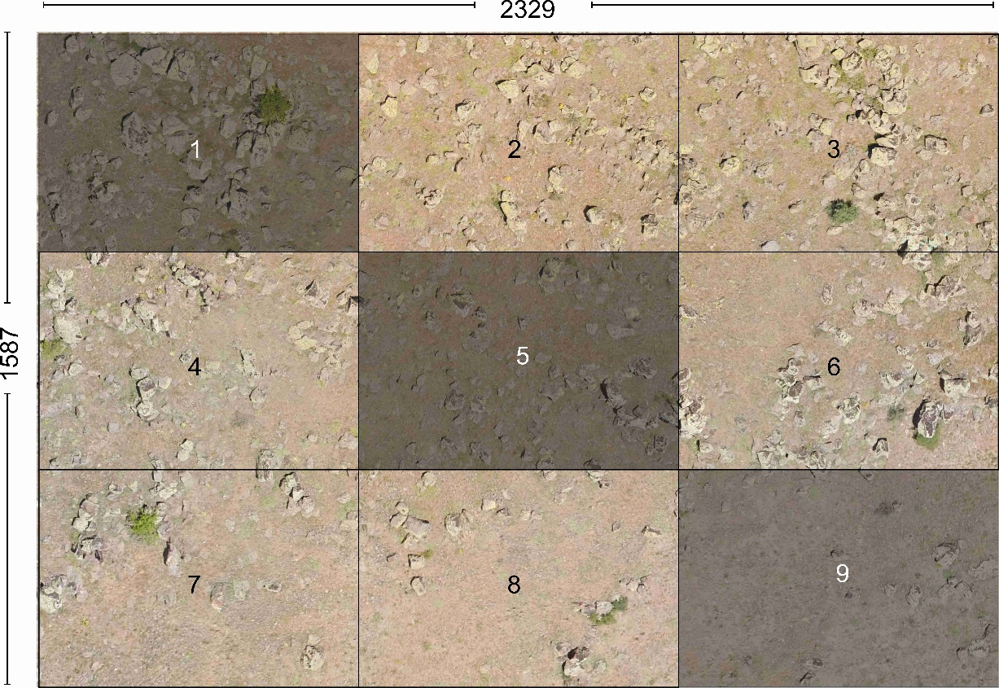

Fig. 2 Train and test sampling areas. 1,5,9 test sampling area and 2,3,4,6,7,8 train sampling area

* 1. U-Net Model

In this study, U-Net architecture (Ronneberger et al., 2015) was used as a segmentation model. This architecture is a type of fully convolutional network developed for biomedical image segmentation. It is named U-Net because the shape of the architecture is like the letter U. The network architecture of U-Net is shown in Figure 3. It consists of two parts. These are the contracting path (left side) and expanding path (right side). The first part captures context, and the second part enables precise localization. The left side consists of 4 blocks and each block contains two 3x3 convolution layers + activation function (with batch normalization) and one 2x2 max-pooling layer. Also, the right side consists of 4 blocks. These blocks include the steps of deconvolution layer, merging with feature map from subsampling path, 3x3 convolution layer + activation function (with batch normalization). Finally, an additional 1x1 convolution operation is applied to reduce the feature map to the required number of channels and generate the segmented image.

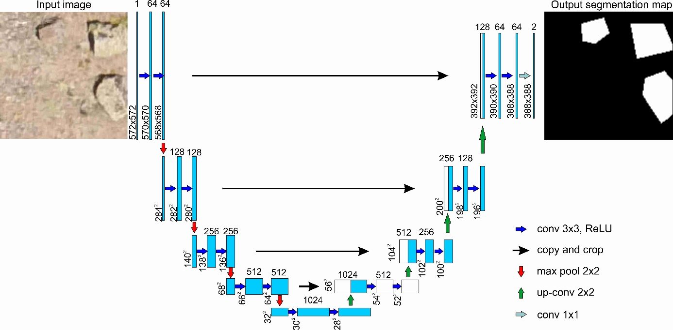

Fig. 3 U-Net architecture

* 1. Evolution metrics and loss functions

In this study DenseNet121 transfer learning models were used for feature extraction and rock segmentation was performed with U-Net. Segmentation model was evaluated in terms of Intersection over Union (IoU) and f1-score metrics. For the calculate loss value dice loss was used. IoU, which is frequently preferred in segmentation problems, is also known as the Jaccard similarity coefficient (Jaccard, 1912). It is the ratio of correctly classified pixels to the sum of the number of pixels in that class and the predicted number of pixels. Mean IoU is the average IoU of all classes and presented in equation 1.

J(A,B) =

The f1-score is important in that it is not False Negative or False Positive, but a measurement metric that includes all error costs, and is calculated as in equation 2.

f1-score=

1. Results and discussions

In this study, we created our own dataset. A large orthophoto image with a dimension of 2329x1587 was created from UAV images. This image needs to be patched for use in the segmentation model. A python script has been written for this purpose. It is possible to create the desired number and size of images with the written script. Random corner coordinates with the size of 128x128 patches were created. Obtaining images with the exact corner coordinates was prevented. Because of this condition, the program gives an error when too many images are wanted to be created. Also, the probability of creating very similar images increases. Using the grid method, 225 images can be obtained from the large orthophoto image. Using the random sampling method 900 images were obtained from the same image.

Also, we used Albumentations (Buslaev et al., 2020) method for data augmentation. Albumentations includes many transform methods. We applied augmentation methods given below:

– horizontal flip

– affine transforms

– perspective transforms

– brightness/contrast/colours manipulations

– image blurring and sharpening

– gaussian noise

U-Net segmentation model was tested on different transfer learning models with the same values of parameters. These models are DenseNet121, Inception-ResNet-v2 and ResNeXt101. Mean IOU and F1 score values were used as metrics. Each model was run three times with the same values of parameters. The best results were obtained with Inception-ResNet-v2 (Table --).

Table – Validation and train scores of the models

|  |  |  |  |  |
| --- | --- | --- | --- | --- |
|  | **Validation IoU** | **Validation f1** | **Train IoU** | **Tain f1** |
| **Densenet121** | 0.7329 | 0.8396 | 0.7799 | 0.8761 |
| 0.7256 | 0.8332 | 0.7672 | 0.8680 |
| 0.7189 | 0.8302 | 0.7748 | 0.8728 |
| Mean | 0.7258 | 0.8343 | 0.7740 | 0.8723 |
| **inceptionresnetv2** | 0.7462 | 0.8438 | 0.8086 | 0.8940 |
| 0.7513 | 0.8503 | 0.8074 | 0.8933 |
| 0.7537 | 0.8494 | 0.8148 | 0.8978 |
| Mean | **0.7504** | **0.8478** | **0.8103** | **0.8950** |
| **resnext101** | 0.7464 | 0.8492 | 0.7963 | 0.8863 |
| 0.7392 | 0.8434 | 0.7860 | 0.8798 |
| 0.7594 | 0.8551 | 0.8155 | 0.8982 |
| Mean | 0.7483 | 0.8492 | 0.7993 | 0.8881 |

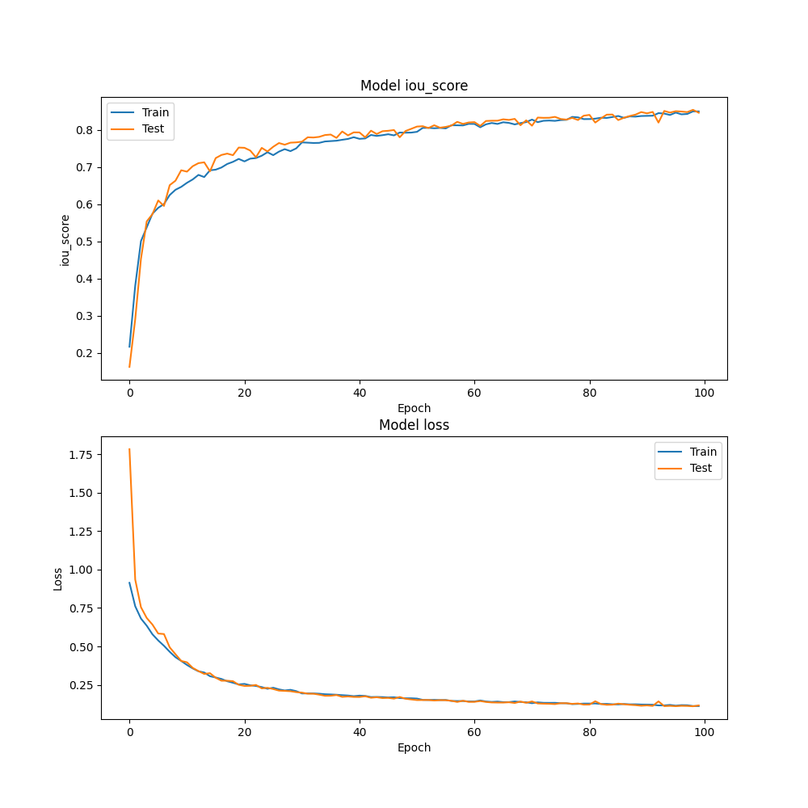

Figure …. DenseNet121 IoU and Loss values

After the rocks were detected, each rock's volume and 3D surface area were calculated. These calculations were performed using Python. Calculated values ​​were saved in the shape file as fill volume, cut volume and 3D area.

In volume calculations, there must be a reference height or surface. In this study, the heights at the boundaries of the rocks were selected as the reference height. The calculations were made using an image containing elevation data. This image consists of pixels containing elevation values. These pixels form rows and columns. The elevation values ​​in each row were used to calculate the total volume. The polygons showing the boundaries of the rocks were masked with elevation data. Thus, data with elevation values ​​for each rock were obtained. Volumes were calculated by proceeding along the rows. The slope was calculated by comparing the elevation values ​​at the beginning and end of the row. A new base elevation was determined for each pixel and the volumes were calculated from this elevation.

In this method, it is necessary to evaluate 3 different situations. In the first case, the first height and the last height of the rows are equal. The starting elevation value is used as a reference height in this case. The volumes above this height are calculated as the fill volume, and the below are calculated as the cut volume. In the second case, the first height is greater than the last height of the rows. In the third case, the first height is less than the last height of the rows. Different calculations must be made for each situation. These situations are shown in Figure ... a ve b den bahset

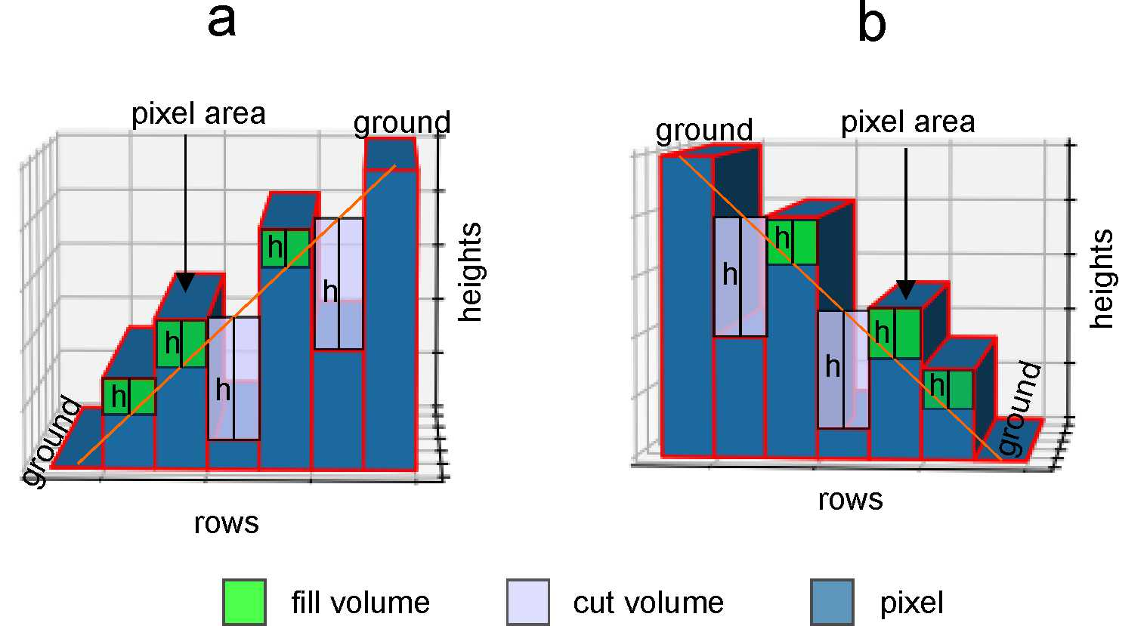

Figure ……..

Volume calculation can be easily done by multiplying the pixel area by the height. Heights need to be calculated for each pixel. The starting and ending pixels along a row are assumed to be ground. These ground elevations are used to find the slope, and each pixel's height is recalculated using this slope. Fill volume and cut volume were calculated using new heights and pixel areas. Slopes, fill volumes and cut volumes were determined using the method in Figure X. The total volumes (fill and cut) are found by summing the calculations made for each row.

The 3D Surface area was calculated by Python script. Calculations of flat surfaces can be found by multiplying pixel lengths. However, different methods must be used for irregular surfaces. The gradient method was used in 3D surface calculation. Height changes were calculated in X and Y directions, gradient vectors were obtained in each direction. Surface areas were calculated by using these vectors. The slope correction equation is used to determine the sloped surfaces.

slope correction=

= gradient in X direction, = gradient in Y direction

The 3D surface area is calculated using the following equation:

3D surface area=pixel area × slope correction

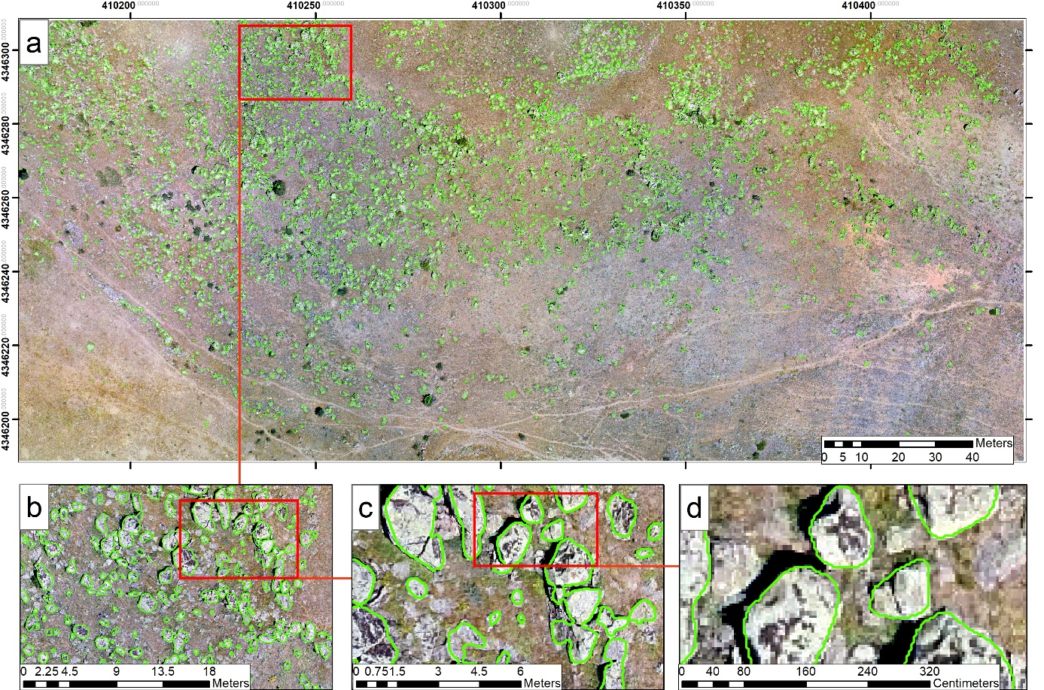

Figure . Result map of the model. a original view, b,c,d zoomed views.

1. Conclusions

This study aimed to segment rock blocks and calculate the volume and 3D surface areas of the blocks obtained as a result of segmentation. The methods used in the segmentation process provided the determination of the boundaries of rock blocks with high accuracy rates. In this way, the geometric properties of the blocks were analysed in detail.

U-NET deep learning network and DenseNet121 model were used as segmentation methods. The boundaries of rock blocks were determined accurately with the trained model.

The volume of each rock block was successfully calculated from the data obtained after segmentation. Similarly, the 3D surface areas of the blocks were calculated. High-resolution DEM data were used in volume and surface area calculations. Determination of block volumes and 3D surface areas is of critical importance, especially for rockfall simulations and engineering analyses. In addition, since the outputs of the study are coordinated vector data, they can be easily used in any GIS software. It can be a basis for different studies and analyses.

This study has presented a reliable method for segmentation and volume/surface area calculations and has also directly contributed to engineering applications in terms of determining the physical properties of rock masses. The segmentation section of the study is recommended for terrains containing a lot of rock blocks. It is possible to detect rock blocks in a short time. In addition, this method can be used to automatically detect different types of terrain. Deep learning models usually require a large amount of data for training. A large amount of data can be generated with the Random Sampling method proposed in this study. Volume and 3D surface area algorithms can be used not only for rock blocks but also for any object on the field. These algorithms only require precise DEM data and object boundaries. For example, these calculations can be made for a single rock block. In these calculations, ground heights and object heights must be determined clearly. When determining the object boundaries, they should be extended towards the ground. If the boundaries only represent the object, the ground heights will not be considered, and the results will not be correct. In some cases, the model can draw the boundaries of the rock blocks narrower. In this case, this problem can be solved by adding buffers to the rock blocks.

As a result, this study provides a basis for volumetric and geometric analyses for rock mechanics, geology and engineering applications, and can be expanded by testing on different rock types and fields in future studies.

Acknowledgements

Code availability

Declarations

References